Diagrams and flowcharts

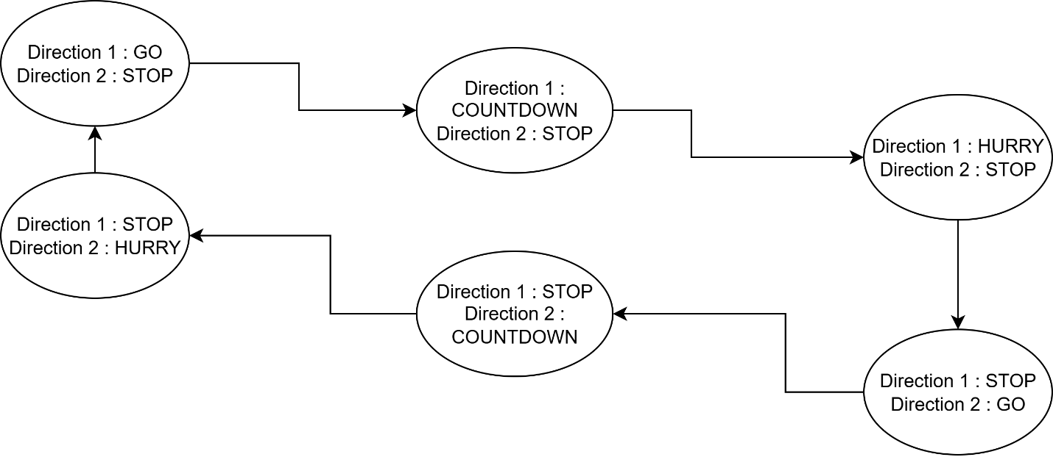

Figure 1 Flow Diagram

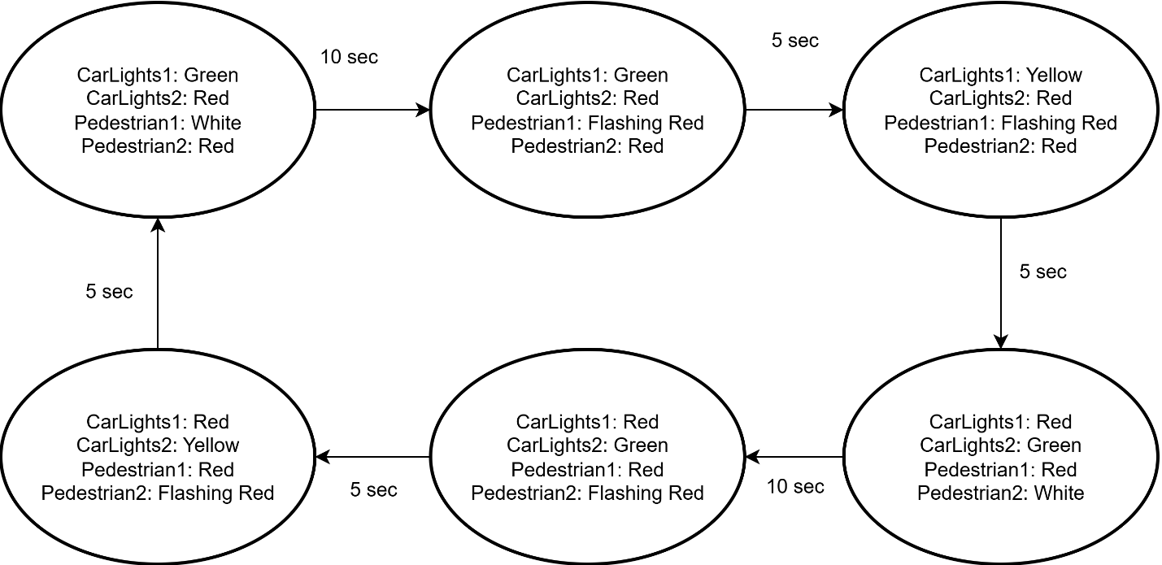

Figure 2 State transition Diagram